California Asian- Pacific Judges Association

November 2020 NEWSLETTER

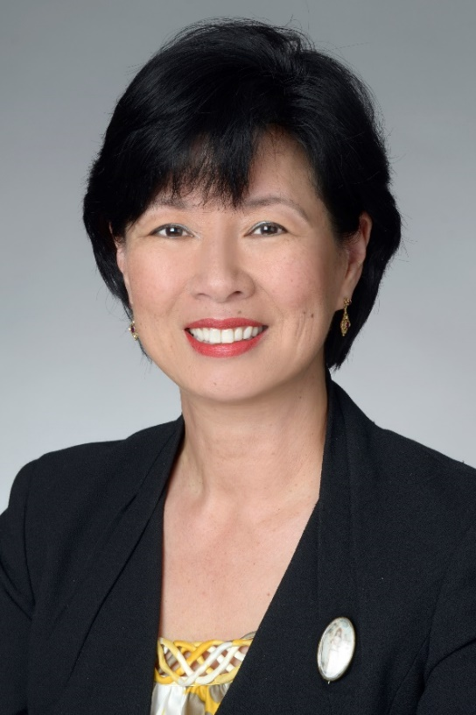President Hon. Holly Fujie

**Member Opportunities**

CAPAJA is creating new opportunities for members.  One such opportunity is the new **CAPAJA Elected Judges Committee**, which will keep track of APA candidates for judicial office, provide advice to them where appropriate and welcome them to the bench.  **Judges Tony Cho** ([tcho@lacourt.org](mailto:tcho@lacourt.org)), **Victor Hwang** (vhwong@sftc.org) and **Teresa Magno** ([tmagno@lacourt.org](mailto:tmagno@lacourt.org)) have agreed to launch this committee.  The new **CAPAJA Administrative Law Judge Committee** will identify and recruit APA ALJs to CAPAJA and address issues unique to them**.    Judge Dorothy Chou Proudfoot** ([dcproudfoot@gmail.com](mailto:dcproudfoot@gmail.com)) has agreed to chair this committee.  The new **CAPAJA Law School and Bar Association Outreach Committee** will keep CAPAJA members notified of bar and law school events they may wish to attend and plan programming featuring CAPAJA members for law schools and the bar.  **Judge Wes Hsu** ([whsu@lacourt.org](mailto:whsu@lacourt.org)) has agreed to help start this committee.  If you are interested in working on any of these committees, please contact the above members directly.

**CAPAJA President-Elect Judge Audra Ibarra**  ([aibarra@sccourt.org](mailto:aibarra@sccourt.org)) is working on a new initiative to provide judges with opportunities not only to be mentored, either as new judges or as judges seeking leadership positions, but also to serve as mentors for junior judges and judicial applicants and candidates.  Judge Ibarra is also planning a program on increasing the APA judicial pipeline.  Contact her if you are interested in working on these projects.

*If you are interested in becoming more involved with CAPAJA generally or in one of our existing programs like judicial endorsements, please contact CAPAJA President Holly Fujie (hfujie@lacourt.org).  All judicial officers, whether just appointed or retired years ago, are welcome.*

**CAJAC**

After a vote at our Annual Membership Meeting, CAPAJA is joining the California Affinity Judicial Association Coalition (CAJAC).  CAJAC, like CAPAJA, is committed to promoting access to justice, treating parties fairly and protecting litigants’ rights equally under our national and state constitutions irrespective of gender, race, creed, color, national origin, sexual orientation or identity. CAPAJA looks forward to working with CAJAC's other affinity organizations toward that goal.

**The Scoville Award**

CAPAJA congratulates its former President, **Orange County Superior Court Presiding Judge Kirk H. Nakamura**, on receiving the 2020 Harmon G. Scoville Award. The Scoville Award is given annually by the Orange County Bar Association and recognizes a member of the Orange County legal community whose career exemplifies the highest standards of the legal profession and who has significantly contributed to the Orange County Bar Association and championed our constitutional system of justice.  This [article](http://www.virtualonlineeditions.com/publication/?m=15276&i=674778&p=22&pp=1) in the Orange County Lawyer has more details.

**Court Leadership**

CAPAJA congratulates member **Judge Elizabeth K. Lee**, who has been elected Assistant Presiding Judge of the San Mateo Superior Court effective January 1, 2021.  Judge Lee is the first APA woman to be elected to this important leadership position.

The Los Angeles Superior Court announced its judicial leaders for the 2021-2023 term, including a number of CAPAJA members: **Judge Elaine Lu**, Assistant Supervising Judge for the Civil Division; **Judge Mark Hanasono**, Assistant Supervising Judge – Felonies; **Judge Michelle Lee**, Assistant Supervising Judge – Traffic for the Criminal Division; **Judge Akemi Arakaki**, Assistant Supervising Judge for Dependency; and **Judge Robert Wada**, Assistant Supervising Judge for the Probate Division.

**Court Dedication**

All are invited to view the dedication of the **Stephen K. Tamura Justice Center** of the Orange County Superior Court on November 6, 2020 at 11:50 am.  The ceremony will be livestreamed on the Orange County Superior Court’s  [website](https://www.occourts.org/).  Former CAPAJA President, **Orange County Superior Court Presiding Judge Kirk Nakamura** led the effort to name the courthouse after the late Justice Tamura, who was, among other firsts, the first Asian American to sit on the Orange County Superior Court and the first APA court of appeal justice in the Continental United States.

**New Judge**

**Scott Yang**, a Los Angeles Deputy District Attorney, was elected to the Los Angeles Superior Court in a run-off on November 2, 2020!  Please welcome him to the bench and to CAPAJA – he will be sworn into office in January 2021.

**NAPABA Conference**

The dedication of the Stephen K. Tamura Justice Center will also be featured at the National Asian Pacific Bar Association (NAPABA) Annual Meeting, where many CAPAJA members will be speaking on programs ranging from A Conversation with Viet D. Dinh, moderated by **Ninth Circuit Judge Patrick Bumatay**, to A Remembrance of Justice Ruth Bader Ginsberg, featuring **California Supreme Court Justice Goodwin Liu** (who will also speak on another panel at the convention).  Also speaking at the NAPABA convention are CAPAJA members **Judges Vince Chhabria, Wesley Hsu, Audra Mori, Wendy Cheng, Lucy Koh, George Wu, Dolly Gee, Jay Gandhi and Deborah Chuang Servino**. Member **Chief Justice Tani Cantil-Sakauye**, will participate

(continued on page 3)

in a Fireside Chat for the NAPABA Women’s Leadership Network program.

Speaking of NAPABA, more CAPAJA members presided over the semi-final and final sessions of the NAPABA Thomas Tang Moot Court Competition this year than judges from all the other states put together!  **Judges Tony Cho, Steve Kim, Lisa Tamashiro Coen, Curtis Kin, Fred Chung, Deborah Chuang Servino, Dorothy Cho Proudfoot and Holly Fujie** served as judges for the competition.

**CJA Conference**

The Fall 2020 issue of CJA’s The Bench magazine was full of articles about and by CAPAJA members.  The cover story, on the fascinating life of CAPAJA member **Judge Tamila Ipema**, is called “Paying it Forward - Her Incredible Journey”. Now-Immediate Past President of CJA, **Judge Tam Nomoto Schmann** gave her final President’s Message. Former CAPAJA President **Judge Elaine Lu** was profiled as a new member of the CJA Board, and she and **Judge Curtis Kin** wrote an article on “Cases to Note on Tort Damages & PAGA Settlements,” the subject of a JES seminar they gave to the Los Angeles and Santa Clara County Courts.  **Judge Tim Saito** wrote a favorable review of “Bruce Lee: A Life” by Matthew Polly, and **Judge Erica Yew** made “A Pitch for Audiobooks.”

*If you have news or know of any CAPAJA member who has been or will be honored, has spoken or will speak at an event or is taking on a new position, please let us know and we will feature it in the next newsletter.*

          We appreciate your past support and look forward to working with you in the future.  We are proud of the achievements of our California APA judicial officers and will work hard to serve you this year.

Sincerely,

**Holly J. Fujie, CAPAJA President**

**Audra Ibarra, CAPAJA President-Elect**

California Asian-Pacific Judges Association

11138 DEL AMO BOULEVARD, #453  
LAKEWOOD, CA  90715

Capaja2020@gmail.com

www.capaja.org